Stephanie Gomez

Growth and Structure of Cities

Professor Hurley

09/30/2020

Corinthian Point Neighborhood

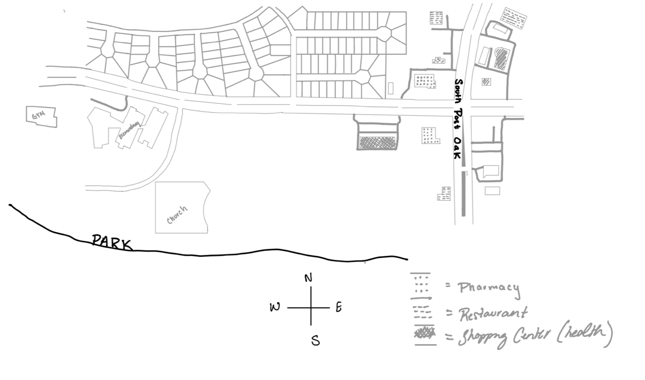

After analyzing my neighborhood in the context of the concepts we have read upon, I was able to better understand the anatomy of my neighborhood. In past reading, it was mentioned that freeways can be “walls” that divide the city but in the context of my neighborhood the intersection of the streets is what determines this division or otherwise known as the edges. In my perspective, I would suggest the edges of my neighborhood to be determined by south post oak road which divides two separate living areas. To the left of the street is what I believe to be the start of my neighborhood. Another edge would be the park/bayou that also serves as an edge of the city of Houston and Missouri City. These boundaries serve to differentiate the start of the neighborhood and the different income levels of the surrounding neighborhoods. This is also evident in person when passing to the left of the dividing street (outside of the neighborhood) you can see homes that are more underdeveloped and storefronts that are architecturally outdated. Within the neighborhood restaurant chains are available with more updated buildings and other social amenities are seen within the neighborhood, therefore, the neighborhood attracts more people to the resources that are available by its updated modern appearance and the convenience of fast-food chains and public spaces. As mentioned by Plater, A community should provide the essentials that are needed for everyday life that residents can conveniently commute by foot or be at a reasonable distance from the homes in the neighborhood. This is demonstrated by the relationship between the drugstore and the medical plaza because they’re within proximity so that it becomes convenient for those to receive their prescription while also getting household essentials. Also, the proximity of the church and gym to the residents’ home is what proves his vision that an ideal community is one with recourse available at a short commute. Also as mentioned by Perry, land should not just be an open space to freely develop whatever comes to mind, instead, it should be created into something that interacts with what is already around it. This is also seen with the interaction between the elementary school and the gym which provides afterschool care for the students and is easily accessible by foot from the school to the gym. The public spaces, such as the church, gym, and park are somewhat near or at the edge of the area. Because of this placement many who interact within. In a larger context, the nodes of the city of Houston are easily through using motor transportation and the access to public transportation since there is a bus stop in the edge of the neighborhood as well with an average distance of 15 minutes to 20 minutes, which is relatively close for the scale of the city. The private spaces in the area would consist of the homes that are in the neighborhood because these are technically restricted in access and many interact within the boundaries of their homes there is rarely any social interaction when passing by the streets. The only interaction within these private spaces is the sidewalks that residents use to go on walks as part of their social activity.