Jackie Fernandez
CITY 185: Assignment 1.3
The First Presbyterian church is located in the center of town with its chapel directly across the street. Originally the chapel was the meeting place for the congregation until in 1863 the chapel was unable to house all those who wanted to attend. Now the chapel is used as a food bank and a place to hold larger church activities such as Christmas dinner, etc. The Trinity Methodist church is another religious space which is on the same street yet on the same side of the road as the First Presbyterian chapel. The Presbyterian church was built long before Trinity, so the building is not as large nor as modern as the latter. Throughout the years I have seen more people attend Trinity church services because it has the capability to house a larger congregation. The First Presbyterian and Trinity church are located on the main street where most restaurants and local shopping stores are placed. As presented in the readings, the location for both of these buildings in the center of town and on the main street indicate their importance.
This town’s location geographically is interesting as well because on one side we are surrounded by mountains and on the other there are a lot of farmland. Looking at Figure 1 for reference, the area surrounding the main street are the densest regarding commercial and residential real estate. Looking at Figure 2, we can see that the farther away from the main street we get, the more geography and nature take center stage. There are parks to the north of the main street and an estuary to the south by the high school and university which prevent any further dense development.
Off of the main street, there are side streets which lead to a middle school, the high school, the university, and behind the university, and elementary school. Since the church also as a nursery school, an individual could literally complete their entire academic career within just a few blocks. While the larger supermarket and commercial stores are located about an additional 5 minutes away from the main street in an area large enough for expansion, I assume that the majority of essential activities were conducted on the main street prior to the twentieth century. The Plater reading provides context and the reasonings for the locations of larger commercial buildings on the edge of a neighborhood and the more local in the center of a neighborhoods. As stated in the reading, we can see in Figure 2 a Target is located at the edge of the town.
The location of the First Presbyterian church is easily accessible and foot traffic as well as vehicular traffic are prominent. To get anywhere in town, you need to go through main street. The gas stations are all on the street, and access to the hospital goes through the main road. There are obviously side streets but those are all residential. It is interesting to see where those who attend the service live because many of them do not live near the church despite its central location. Most live in the senior living center on the outside of town or in the more rural/suburban areas of the town. Those who attend the pre-school in the church during the day are children living within walkable distance, also some living in the rural areas but most within walking distance.
Figure 1: Map of Hackettstown (Scale: 200 ft)
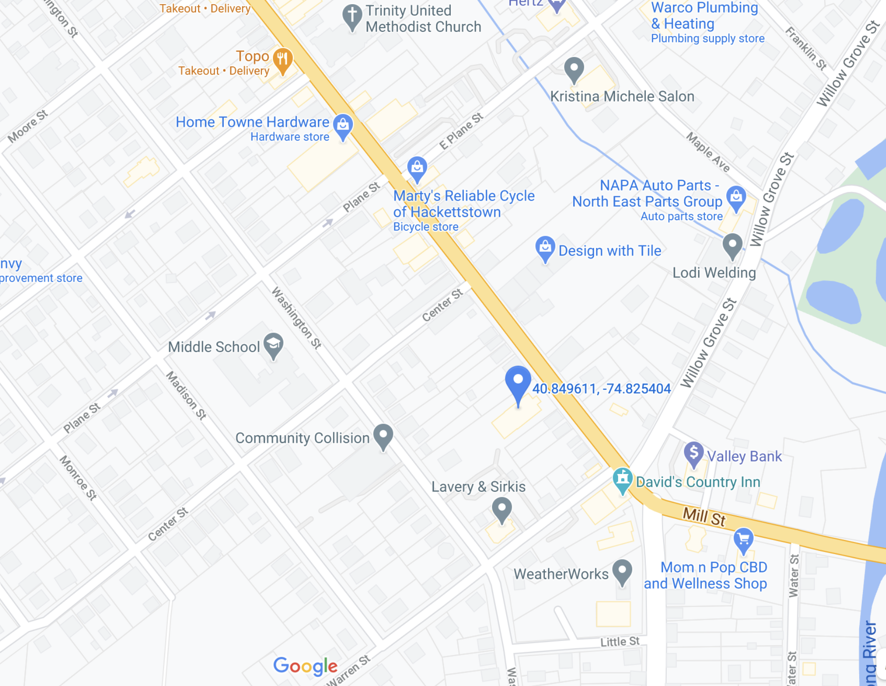

Source: Google Maps

Figure 2: Map of Hackettstown (Scale: 1,000 ft)
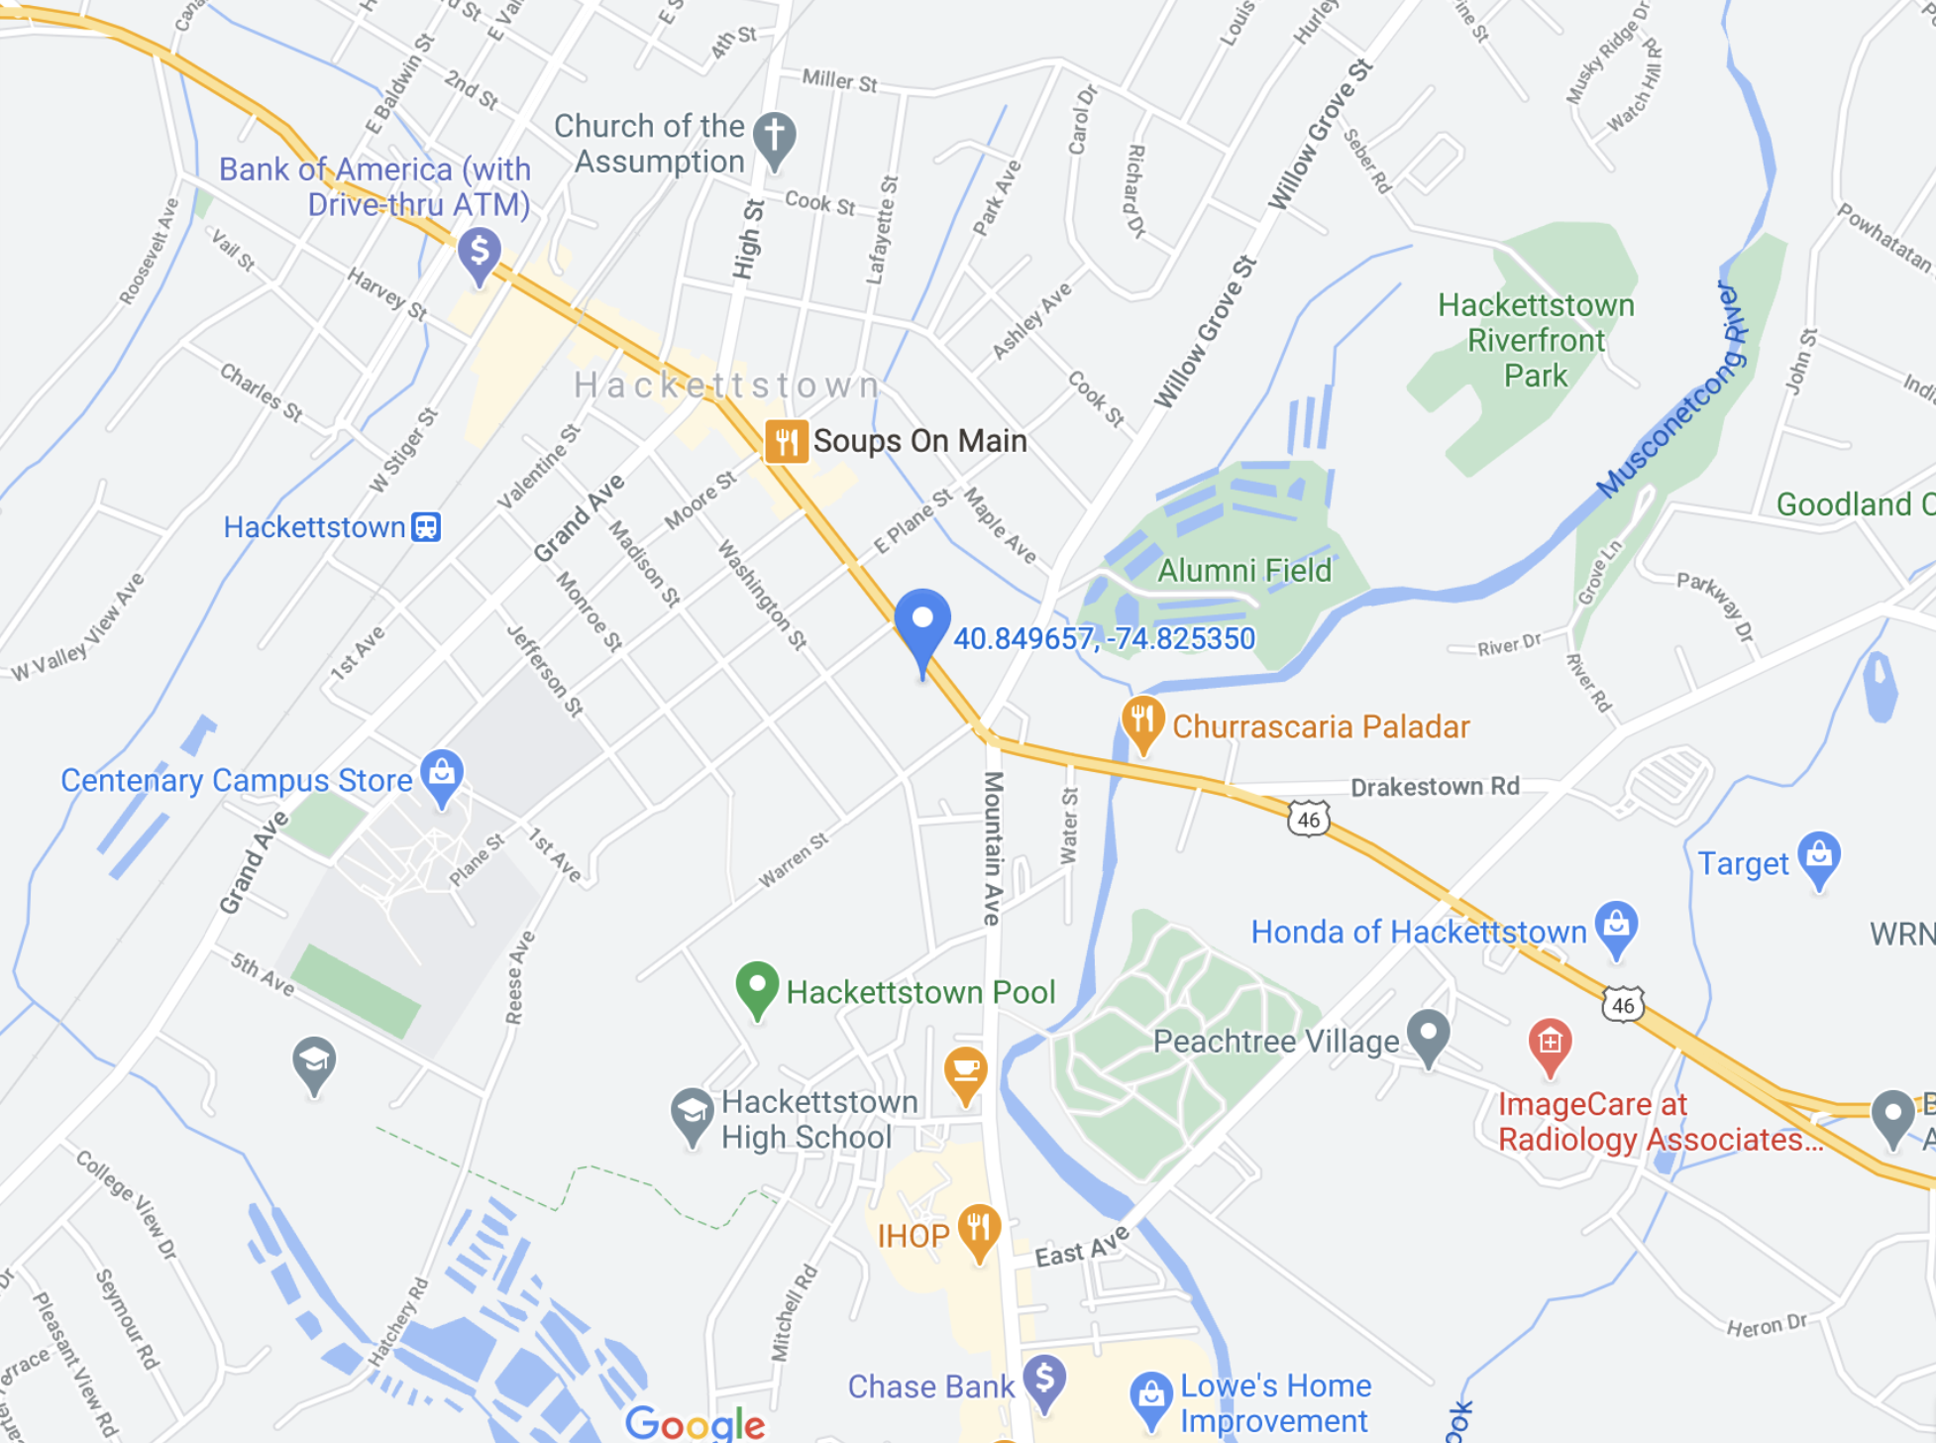

Source: Google Maps

