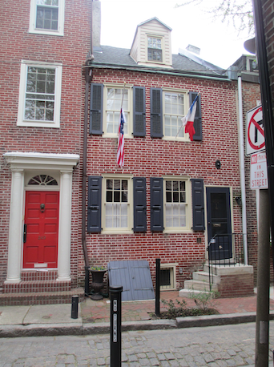**• ce1. 251 South Quince Street**

[between Spruce and Locust, E of 12th].

Built ca. 1813-20   
15’ front, initially part of a row of 5 houses, 245-53 S. Quince Street, with smaller houses at rear.

**Network of inner-block streets, alleys and courts . . . building for rental . . . African American residents from ca. 1840s.**

• ce1a. Photo 2019, Caroline Slama.

• ce1b. Hexamer & Locher atlas 3 (1858): pl. 32 (PGHN).

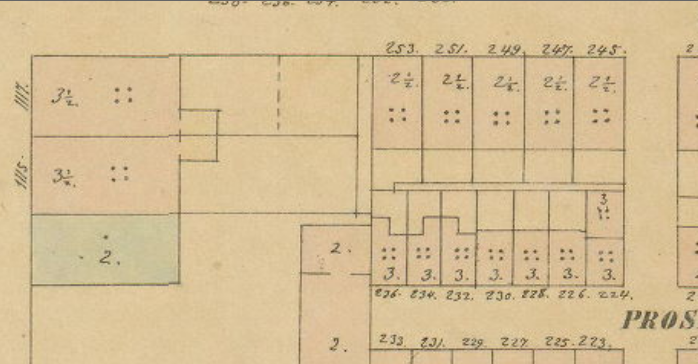251 South Quince appears in an 1858 real estate atlas as part of a row of five 2-1/2 story attached houses that were once probably nearly identical. Initially the five had side-gabled garrets, but the three houses to the north were expanded to a full third story after 1858. The five had no backbuildings at that date, and so less reason for their developers to pair rear ells and front doors. Behind these five houses were seven smaller ones facing what was originally identified, perhaps with mean-spirited irony, as “Prosperous Alley.” With frontages of less than 11 feet, compared to the 15 feet on Quince, this was not Easy Street. The rear alley was referenced in early deeds as “Ormiston Court,” underscoring that the development was probably all laid out by Edward Burd (1749-1833), whose suburban villa built in 1798 (and still standing in Fairmount Park) was named Ormiston after his grandfather’s Scottish estate.

**x**

Although insured and drawn in plan in this 1866 survey, deed records compiled in 1962 by Edwin Iwanicki indicate that 251 South Quince was built between 1813 and 1820 at the instance of Burd and his son Edward Shippen Burd, who invested substantially in real estate development. This property was briefly mortgaged to plasterer Charles Grugan in 1819 and shortly later reclaimed by the Burds in an 1820 sheriff’s sale; he probably resided here as well (his address was listed in 1819-21 as “Quince ab Spruce”), and one wonders if he might have been among the artisans who built these houses. The Burd trustees held 251 into the early 1860s, and it seems likely that these houses were intended for rental to residents who lacked the capital to buy.

As with many smaller urban houses, the early history of 251 is told in two distinct series of names, one of owners and a mostly different one of residents. The latter, partly reconstructable from census records and city directories, identifies the longest-term residents of 251, from the late 1840s through the late 1880s as the family of Samuel and Elizabeth Edwards, identified as “mulatto” in the 1860 census. City directories indicate that he worked as a porter and she as a washerwoman, that neither could read nor write, and they were joined there in 1860 by four other family members, two females aged 26 and 16 employed as washerwomen, and two males, ages 19 and 16, employed as a carriage driver and as an errand boy. They were succeeded by other Black families through the 1930 census, apparently none of 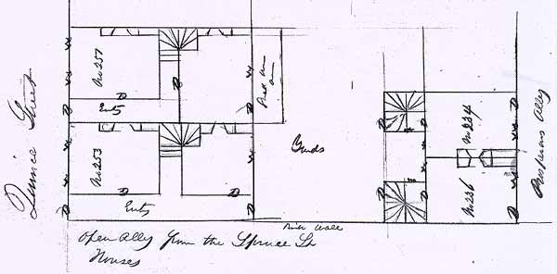them matching the names on the deeds.

• ce1c. Plan, 1866, from Franklin Fire Ins. survey 239: 34312 (HSP).

Generally speaking, houses 15 feet across and two rooms deep, with winding stairs tucked in on the front side of the second room’s fireplace, are not surprising on such modest mid-block lots in the early 19th century. What is more striking in 251, though, are the non-bearing partitions, now mostly removed, that define side halls and a transverse corridor to the winder. In such a small house, this seems a substantial sacrifice of space, and this was even more marked in 253, to its south, insured at the same time, where the longer side hall took space from the back room. (That house was transformed into a stable later in the 19th century, but has been reworked as a house again since.) Even amid the long tenure of the Edwards family at 251, one wonders if these partitions between rooms and passages reflect a desire for greater privacy, perhaps involving cohabiting family units or boarders as adaptations to the original plan. It is not mentioned in the fire insurance survey, but it seems likely that the kitchens were in the cellar rather than in the ground-story rear rooms.

The two smaller houses to the rear, now removed, shared the yard with the front houses. But they were truly constrained places, just 10 feet wide, with a single oblong room on each of three floors, and a winding stair in a projecting rear projection. Curiously, the 1858 atlas shows the four northernmost Prosperous-Alley houses as somewhat different in form, apparently with internal stairs.

-- JC

Other References:

Deed research 1962, PHC.

U.S. Census research made available by owner.

=====