**• ce5. 1200 block of Pine Street, 1201 block of Lombard**

**1820s-30s inner-block development . . . plan types . . . vocational and social geography . . . change and persistence.**

🡪 [*Exterior visit only.*]

Behind the street-fronts facing 12th and 13th, Pine and Lombard, one finds within the large block interior a whole different built landscape, with dozens of modest houses, most with frontages of less than 16 feet, and most originally without rear “ells” or attached backbuildings. A remarkable amount of early fabric within this and some nearby blocks remains largely intact externally, if mostly adapted and modestly expanded to accommodate modern kitchens and bathrooms.

These small buildings fill in an intimate armature of narrow and often short, discontinuous streets and courts (with continually changing names) that integrated demographic diversity into the entirety of a block in the densest parts of the antebellum city – in ways that became less common as the city and the scale of development expanded in the third quarter of the 19th century.

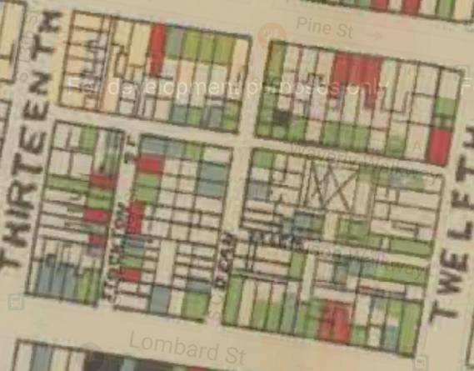

These buildings were the built matrix for social and economic patterns that are characteristic of such blocks, and that have been studied graphically. One might start with the map of the 7th ward that W. E. B. Dubois published in 1899, offering his characterization of the economic status of African Americans on this block, from red for middle-class and above, green for working class, and blue for the poor.

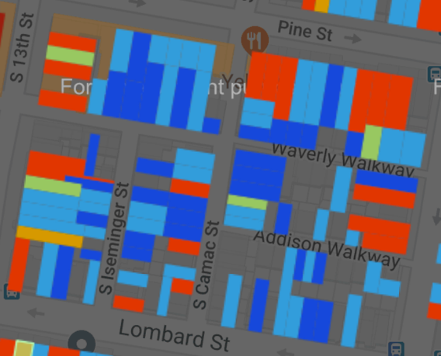• ce5a. Excerpt of map of Philadelphia's 7th Ward from W. E. B. Dubois, The Philadelphia Negro (1899) (A. Hillier and S. Boddie, www.dubois-theward.org).

Clearly, the inner streets and Lombard Street, to the south, were predominantly black, but one also finds perhaps more integration among the larger houses on Pine than one might expect on this street, but Pine Street was quite variable from block to block, and other blocks of Pine showed far fewer black residents.

• ce5b. Race/Nationality from 1900 census for this block (WorldMap, Harvard).

Casting a wider and slightly later net was the mapping of race and national origin on the 1200 block with data from the 1900 census. Here households in blue were African American, while those in red were American-born whites, mainly clustered on the outside of the block, along Pine, 12th and 13th, while four in green were households headed by Irish-born residents.

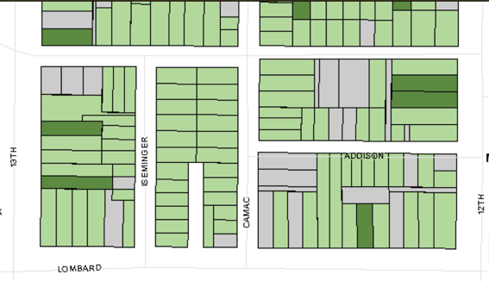

• ce5c. Owner-occupancy vs. rental in 1900 census, from “Mapping Dubois” website (A. Hillier, U. Penn CML, 2014).

The sources of data behind these maps were a few years apart, but they generally align, as both do with a third map, one of just the southern two-thirds of the block, constructed several years ago based on the same census data from 1900. This looked at owner-occupancy versus rental (in dark green versus light green), reflecting the striking dominance of rental in the inner block, for some inner lots an economic condition shared across race and nationality.

One might imagine other questions relying on varied sources in pursuit of further insights at the block scale. Examining early ownership records would indicate the original parties who successively subdivided larger parcels into house-sized lots, and the agency behind the construction of many still recognizable speculative rows, effectively sketching out the successive increments of development in an annotated map parceled into multi-lot projects. At subsequent points in history, deed, city directory, and census research (both U.S. and mid-19th-century Abolitionist censuses) would further identify owner-occupants, landlords, and their tenants. With sometimes challenging address translation, such resources could populate the block historically well before 1900, and help cast residents in terms of vocation, national origin, ethnicity, and other characteristics. Through successive directories, one might track different family journeys to and from this block. And newspaper references sometimes noted sales and touted features of places on offer, as well as glimpses of economic activities and incidental narratives of life here. Meanwhile, the fabric itself, along with building permits, record aspects of construction practices and physical evolution.

All these ingredients of a block mini-history sketch a large project that might revealingly be addressed to any of several inner blocks with this level of survival, sketching out narratives whose thematic visibility and physical survival this close to the city center depend on preservation vigilance.

* * *

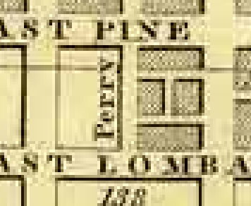

The built history of the 1200 block between Pine and Lombard picked up dramatically in the second quarter of the 19th century. Several properties on the block were insured in the early 1830s, and the 1828 Allen/Tanner’s map of Philadelphia shows its entire east half developed but the west half vacant, suggesting that this was the period of its initial build-out, caught there in mid-stream.

• ce5d. Detail of William Allen, “Plan of the City of Philadelphia and adjoining Districts,” 1828 (U. Wisconsin/Milwaukee).

• ce5e. Block from 13th and Lombard to 12th and Pine streets, from Hexamer & Locher atlas, vol. 3 (1858), pl. 33 (PGHN), with fire insurance and other plans of buildings within the block.

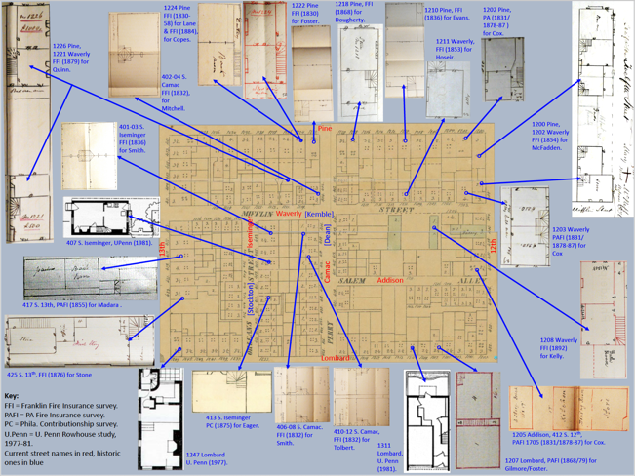

Assembled on the following two pages are about two-dozen 19th-century fire insurance surveys from three companies, along with some recent student drawings, arrayed around the 1858 map of the block excerpted from Hexamer and Locher atlas. This offers a sense of the spaces within these buildings, many of them effectively capturing the disposition of internal spaces there from the mid-19th century, displaying a range of commonly used plans for such modest buildings.

-- JC

====================