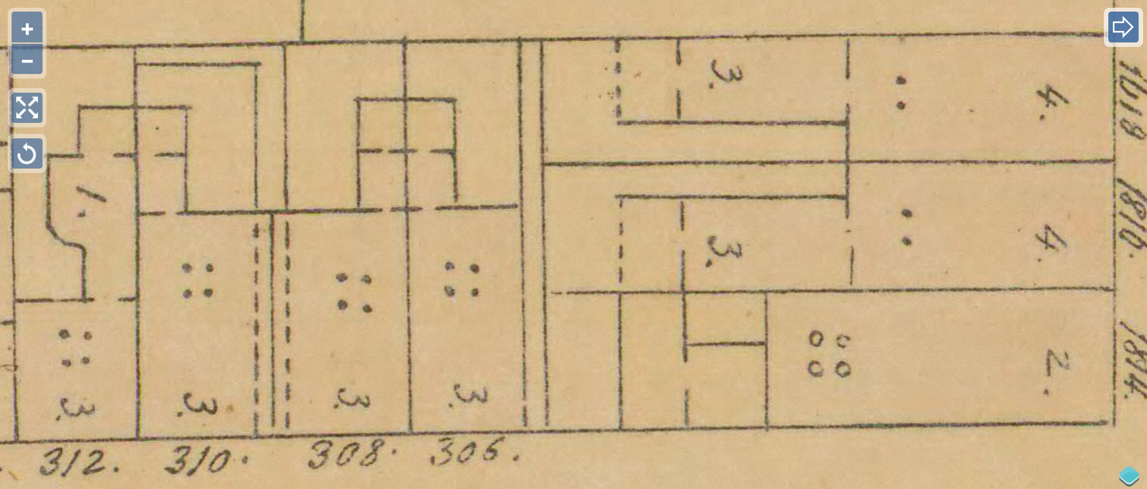
• cw1. 308 South Smedley Street
[W of 16th, S of Spruce]
Built ca. 1836-37.
House 17’5 front, initially probably as a pair with 310.
x
x

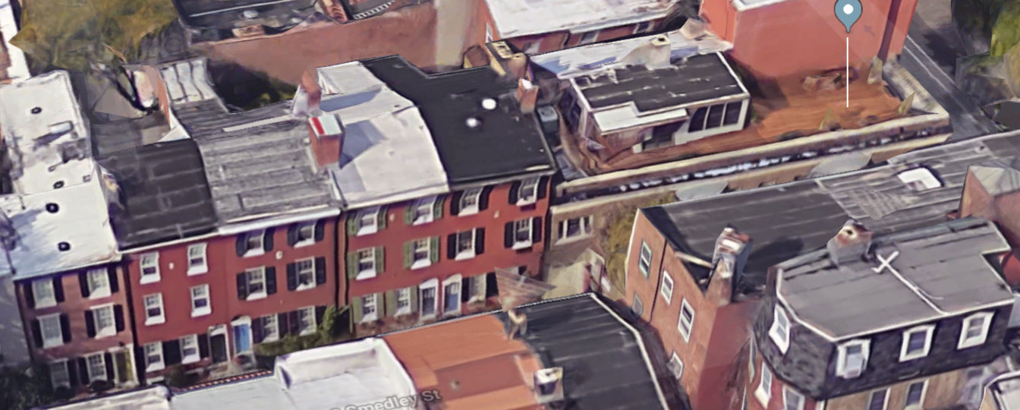
Antebellum western expansion . . . blacksmith’s shop . . . artisan housing . . . 19th, 20th century demographic shifts . . . Colonial Revival.
x
x

• cw1a. Hexamer & Locher atlas 3 (1858): pl. 37 (PGHN).
• cw1b. Aerial view, West side of Smedley St. (Google Maps).
• cw1c. Plan, 1837, Franklin Fire Insurance survey 0: 1821 (HSP).
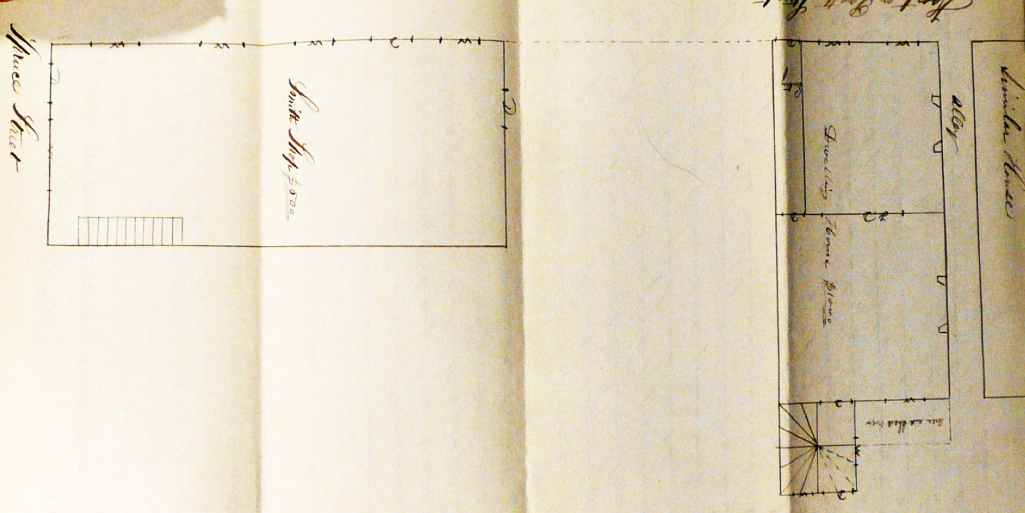
In April 1837 two blacksmiths in partnership, Patrick Fearon and Samuel Maull, insured two disconnected buildings west of 16th street. The larger one was their blacksmith shop, an open two-story brick structure measuring 19 x 45’, with a frontage at present-day 1614 Spruce Street. That strikes one today as a remarkably utilitarian function for a front on that block, filled out within three decades with imposing four-story townhouses. It recalls a time when this western part of Center City was a quite different place. The smithy fit its function without pretense: it had an “earth floor and a board floor” and four forges on the first story, a step ladder to the second story, and a single pitch roof sloping to the east.

In addition to the shop, insured for $500, the 1837 survey described the house, insured for twice that amount, located “at the rear end of the lot” -- as if the house was the next structure south of the shop, but by 1858 it was the middle one in what appeared to have been a three-house row. Despite looking as if they were initially identical, there is a straight joint between 308 and 306, the northernmost of the three (and no such discontinuity between 308 and 310, labeled as “similar house” in the 1837 survey). The houses at 308 and 310 were probably built together, while 306, closer to the shop, was built shortly after the other two.

The surveyed house was ample, three stories high and 17’5 across, with marble sills (on the first story only) and “Reveal windows” in front (but “cased and scantling windows” at rear), according to the fire insurance survey. A 3’6 passage “built over” between 308 and 310 provided direct access to their rear yards. An extraordinary pair of pointed brick vaults span the passage, buttressing the chimney masses on either side, which unite above and emerge as one above the roof. (It seems to have been more common to place the chimneys on the walls opposite such yard passages, between paired front doors, but when building only the pair at first, it was probably desirable to save labor by joining the chimneys.)
Each house initially had small projections into the rear yard that held only the winder stairs of each, but these volumes were later extended by wooden additions. The basement, partly exposed above grade in front, likely held the kitchen. It received more light from a sizable window facing a sunken “area” to the rear, this sheltered by a wooden shed roof.

• cw1d. Detail of insurance survey plan.

The plan showed a half sidehall that provided a social buffer to the front room, which was narrowed by it. Despite the lack of a “D” along the hall’s inner wall, the description does appear to indicate a lateral doorway into the front room. That entry hall reached only to the house’s middle depth to open into the wider rear room. The wall between the front and back room was marked “FD” for “folding,” or double doors that connected them.
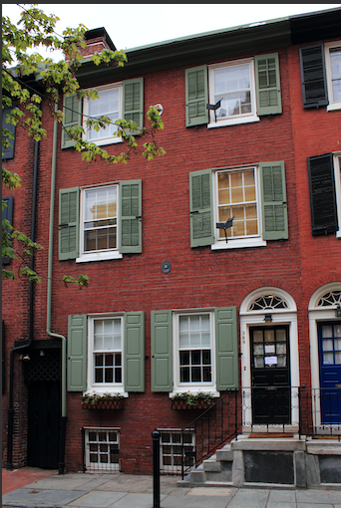
• cw1e. Photo 2019, Nicola Tenaglia.

Research by D. Roger Mower, resident at 310 in the 1970s, indicates that his house was built by two carpenters, Edward R. Elliott and Charles Wright, who acquired that property on ground rent in November 1836 from Isaac Lloyd (or Loyd, perhaps the prolific speculative developer of that name), with the stipulation that they immediately build there, and it is likely that they were also responsible for building 308, insured the following April (and perhaps later 306, so similar in form).

City directories from the 1830s indicate that Fearon, the first-named partner, lived just to the northeast on the curiously named Knoodle Street (now, less romantically, South Sydenham), while the Maull family would remain at 308 into at least the late 1860s.
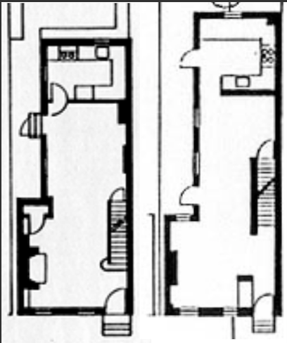
Further down the block by 1858 on Pratt (later Bradford, and ultimately Smedley Street), some of the houses were smaller, with shallower front volumes but deep ells, while others there and opposite had deeper volumes but no ells. Plans of two of these were drawn by Penn architecture students 40 years ago, showing spaces far more opened internally than they were in the mid-19th century.

• cw1f. Plans of 326 and 318 S. Smedley, 1978 and 1980 (U. Penn Rowhouse Study).
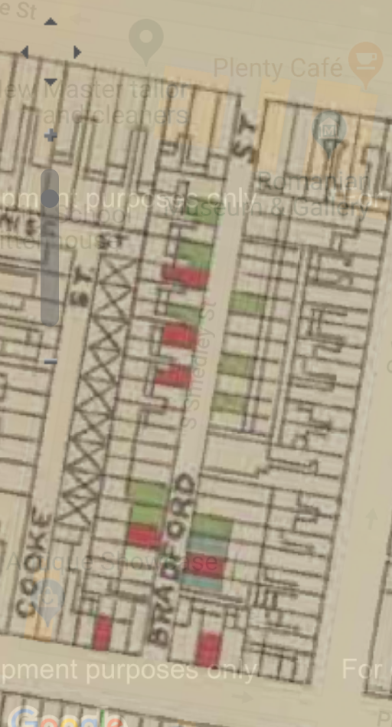
Research by James Duffin on census records from 1860 show an overwhelmingly white block, with many residents of Irish birth and just a handful listed as black or mulatto, but by the time of W. E. B. Dubois’s mapping in the late 1890s, nearly half of about 35 houses on the block were indicated as occupied by black families. Dubois tinted five lots red for “middle-class and above,” ten green for “working people, fair to comfortable,” and two blue, for “poor.” In newspaper advertisements from the early twentieth century, “colored” residents of the block often sought “situations” or proffered their services.

• cw1g. Excerpt of map of Philadelphia's 7th Ward from W. E. B. Dubois, The Philadelphia Negro (1899) (WorldMap/Harvard).
• cw1h. I. Korostoff, U.S. Census Racial Data for 300-block of S. Smedley, 1900-40.

Shortly later, though, another set of changes had started to recast the block, with newspapers reflecting a stirring of new investment and impending displacement of the black residents. In 1905, for instance, society architect T. Mellon Rogers had dwellings at 333 and 335 S. Smedley demolished to make way for new houses, and this trend would continue over the next two decades. In 1924 an ad touted a “modern residence” at 326 S. Smedley: “7 rooms, 2 baths. Moderate rent. City convenience with the quietness of the suburbs,” clearly anticipating tenants for whom the suburbs were a reference point.
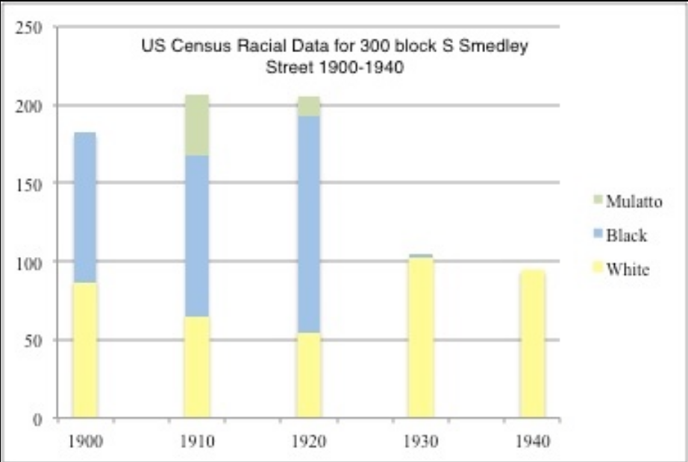
Many of the small houses remained but the population changed dramatically. Census research complied by Izzy Korostoff demonstrates the scope of this change by 1930, and it quickly became evident architecturally as well, as houses were recast, often in Colonial Revival or Arts & Crafts stylistic garb evident today, presenting Smedley as a “quaint little Philadelphia street.”

This transformation reflected a process celebrated in a 1922 article called “Beautifying our Back Streets.” It pointed to a mid-block street downtown, near 19th, newly recast as “Lantern Lane,” that had been turned into “as quaintly charming a community as is to be found in all Philadelphia, and located in a street where less than a year ago Negroes of the poorer sort huddled in squalor and congestion.” Private initiatives were modeling “a novel and picturesque turn to real estate development in the central residential district and shown how to prevent valuable property from deteriorating into slums.” In the example posited as exemplary, “eighty-seven Negroes who had occupied the sixteen houses moved to other places,” and houses that rented for $12 a month were now renting for nearly ten times that amount, and “practically all” were rented “some time before the operation was completed.”

Among the new residents in the 1920s was an architect, R. Brognard Okie (1875-1945), best known for his Colonial Revival and Cotswold work with the firm Duhring, Okie, and Ziegler (1898-1918). Okie made 308 his home and 306 his office, and internally the houses bears the marks of his design hand, many looking back romantically to the hand-wrought classicism of the 18th century.
-- JC, with research by Izzy Korostoff and James M. Duffin.
=====
Other References:
Deed Registry sheets, block 3-S-19.
Philadelphia Inquirer, 4 Aug. 1905, p. 6.
Philadelphia Inquirer, 31 May 1924, p. 27.
Philadelphia Inquirer, 24 June 1939, p. 13.
“Beautifying our Back Streets, Philadelphia Real Estate Record & Builders’ Guide, 20 December 1922, pp. 819-20.
Drawings of 318 and 326 S. Smedley, by S. Fogel in 1978 and A. Rosenblum in 1980, U. Penn Rowhouse Study.

