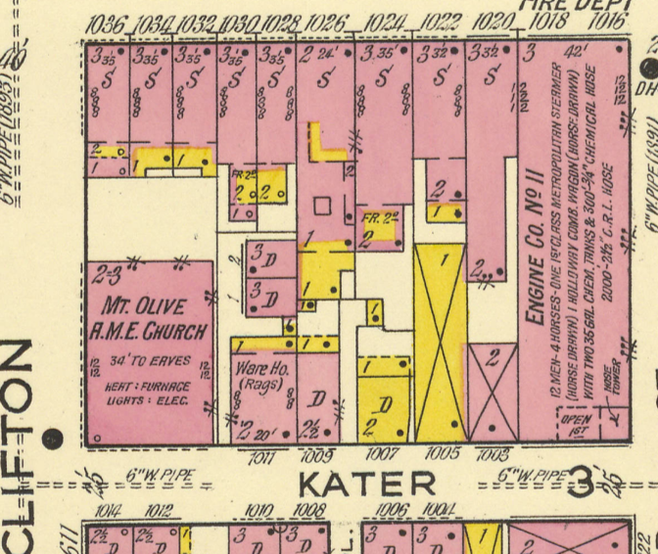**• se2. Waters Memorial A.M.E. Church**

**(originally Shiloh Baptist Church)**

609 South Clifton St. [just S of South St., E of 11th]

Built 1845-46.

**Antebellum African American church . . . congregation’s architectural ambitions . . . Greek Revival restraint.**

**x**

# • se2a. Sanborn atlas, Philadelphia, vol. 5 (1917): pl. 403 (PSU).

• se2b. Photo from NW, 2017, J. Cohen.

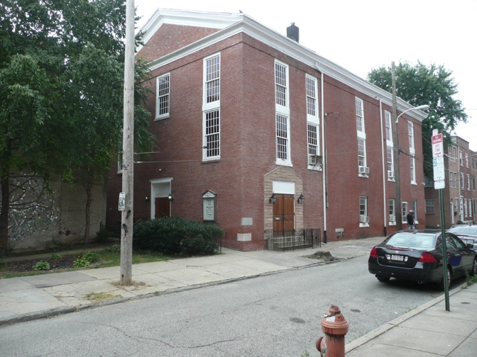In 1846 the trustees of the Shiloh Baptist Church completed their new building, a handsome gabled, rectangular structure that placed its tall, elevated sanctuary over a lower ground story accommodating other congregational functions. The church was set back behind smaller buildings, now gone, facing South Street, that limited its visibility from this well-trafficked thoroughfare.

Glimpsed on an angle from Clifton Street, the broad, boldly moulded pediment (once with thick “block dentils” now present only at rear) clearly announced its presence as a place beyond the utilitarian. One entered on axis from the north via a shallow front yard where, an 1846 fire insurance survey reported, there were “large wood pilasters and entablature on the outside with brackets to it.” The design eschewed arches, combining pairs of double-hung rectangular sash windows in tall vertical registers with wooden spandrel panels between them. The noble simplicity of the Greek Revival still retained its potency here, as an assertive gesture of public presence on the small, obscured site.

A 1905-07 account by Franklin B. Guinn tells of the church’s early years. The congregation formed in 1842 when 43 members of the Union Baptist Church, above Vine Street near 11th, set out to establish a new African American Baptist church “in the southern section of the city” (p. 61). After meeting in a “circumscribed apartment” (p. 42) in a hall on 11th below Pine, the congregation reported that it was “deeply interested in the scheme of building a house of worship, and that all eyes are being turned to our denomination to witness their philanthropy in erecting a chapel for the proscribed and destitute of their name . . . which shall excite the admiration of all visitors to our city for consecutive generations” (p. 52).

Their congregation’s attention soon turned to an “unimproved lot in Clifton street, below Cedar” (South), a lot which, “like many other small streets in the Southwark or Moyamensing district at that time was conspicuous for its filthy condition” with “huge piles of dirt, occasionally ornamented with a deceased cat or dog, with numerous pigs, geese, chickens. etc. roaming at will” (p. 65), with a number of old frame structures nearby. They cleaned up the lot, dispersed the wildlife, and on 29 September 1845 laid the cornerstone of their new church, looking forward to occupying “the ‘finest building’ owned by any colored Baptist church in the United States” (p. 68). Their ambitions for their building were high. It cost between $5,000 and $6,000; they would long be burdened by debt from it.

• se2c. Plans, 1846, from Franklin Fire Insurance survey 45: 6556 (HSP). [N is at bottom.]

• se2d. Interior photo, 2018, J. Cohen.

# Screen Shot 2017-07-30 at 9.43.59 AM.png The building measured 38 feet wide and 55 deep, its upstairs sanctuary reached via twin stairways at the northern corners of the broad vestibule. There were 64 pews in the south-facing sanctuary, these accessed from two side aisles. Galleries on cast iron columns provided 36 additional pews on three sides of the sanctuary.

• se2d. Interior photo, 2018, J. Cohen.

# Screen Shot 2018-08-29 at 6.34.14 PM.pngBelow, te lower level had a large “lecture room used as a public school,” divided longitudinally into thirds by girders on pairs of cast iron columns. There were two classrooms (with external doors) along the south wall. The roof structure was described as “about 10 ft pitch, 5 principal rafters with Collar beams, and girder 3 x 12 and braced Crosswise with sap boards, thus. with a purline on each side and ridge pole, 3 by 4 rafters.”

In 1847 the congregation had reached 119 members. A stubborn debt for about two-thirds the cost of construction remained. A new minister, Rev. Jeremiah Asher, was engaged, and he traveled to England and Scotland to raise funds for the church, a trip he chronicled in an 1862 book. In adopting the new position he cited as his leading reason that “the Shiloh Baptist Church occupied the most substantial and commodious church edifice in the denomination, occupied by the colored people in any city in the Union. . . I felt that if at least the building could be saved, a good work would be effected” (Asher, p. 80).

Nonetheless, the congregation persisted and grew further, to the point that in 1885 they acquired a larger church building, measuring 61 by 71 feet, the former Episcopal Church of the Ascension nearby on Lombard above 11th Street. Meanwhile, the Clifton Street church was sold to the Murray A.M.E. congregation, later Mount Olive A.M.E., itself founded in 1825. They remodeled the building in 1921. It is now the Waters A.M.E. Church, which renovated the church in 1953. It continues to house a very active congregation and community resource.

-- JC.

Other References:

Franklin B. [Guinn,](https://archive.org/search.php?query=creator%3A%22Guinn%2C+Franklin+B.%22) The Rise and Progress of Shiloh Baptist Church of Philadelphia (Philadelphia, 1905-07).

Jeremiah Asher, An autobiography, with details of a visit to England : and some account of the history of the Meeting Street Baptist Church, Providence, R. I., and of the Shiloh Baptist Church, Philadelphia, Pa. (Philadelphia, 1862).

------