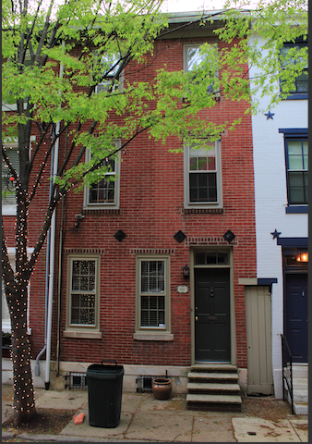**• sw1 1810 Addison Street**

Built ca. 1852-53, insured 1864.   
15’ front, part of a row of perhaps 4 houses, 1810-16 Addison.

**Speculative urban vernacular (‘the other SUV’) . . . secondary and mid-block residential streets . . . two-room plan . . . open plan vs. side hall . . . ”alley built-over“ . . . heart of Dubois’s 7th ward. . . black middle-class families.**

• sw1a. Photo 2019, Nicola Tenaglia.

• sw1b. Plan of 1810 Addison, 1864, Franklin Fire Insurance survey 227: 32254 (HSP).

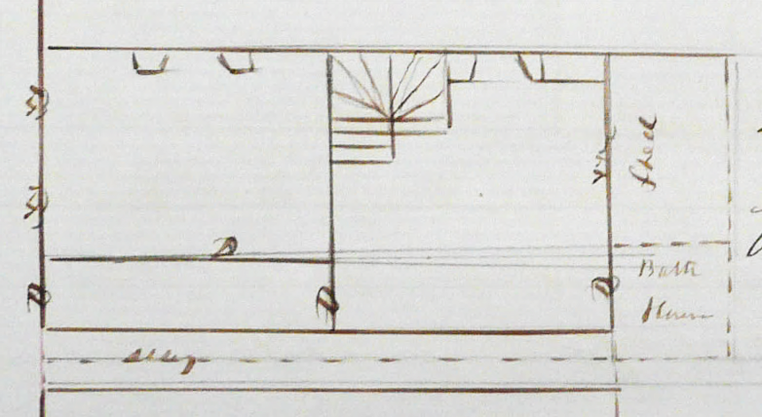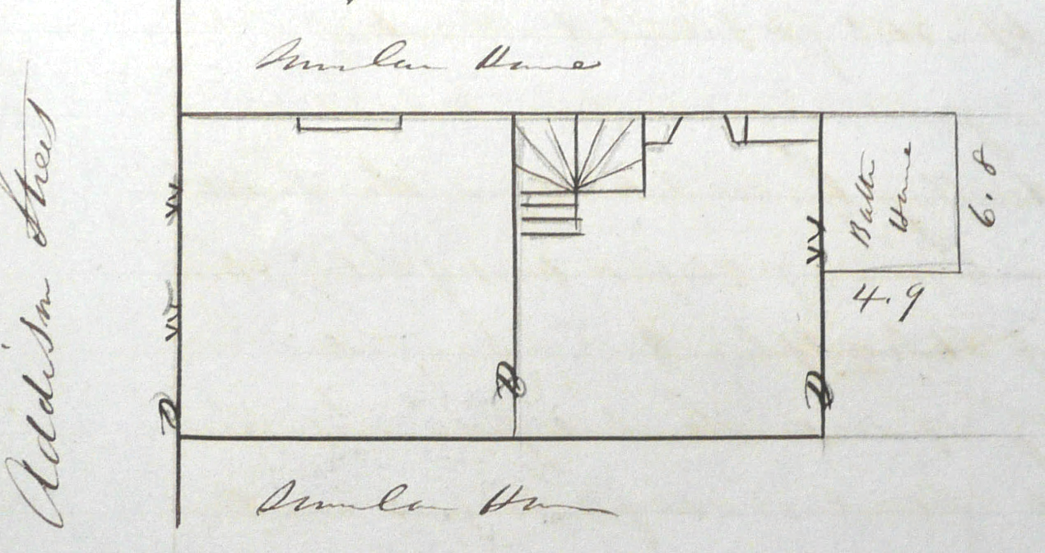 Although surveyed in 1864, 1810 Addison was shown with the same footprint configuration in the 1858 Hexamer & Locher atlas, one of 19 very nearly identical house footprints on the south side of the block and 18 more on the north side. Others on this block were surveyed for insurance in 1853 and 1854, likely the approximate date when most were completed. All had frontages of between 14 and 16 feet and depths of 28 feet, excluding the small projecting frame “bath house” at rear described in the surveys. Adjoining this on some of the houses from an early point was what appears to have been an open rear porch.

Houses about 15 feet across and two rooms deep, three stories high were staples of speculative urban development away from the avenues of social visibility in the mid-19th century city. They often had winding stairs in the second room, tucked in forward of the rear fireplace as here. Within the same footprint and behind similar facades, however, plans of these houses varied more than one might expect. The 1854 survey of 1818 Addison, a few houses west of 1810, showed an entry vestibule and a side-corridor leading to a wider longitudinal stairhall.

• sw1c. Plan of 1806 Addison, 1853, Franklin Fire Insurance survey 135:17848 (HSP).

An 1853 survey of 1806 Addison, a couple of houses to the east, showed an open plan, with no side hall, perhaps the original configuration of 1810 Addison. Unlike 1810, though, the survey shows a full hearth in the back room but only a shallow projection in the front room, perhaps meant to accommodate only a stove, as was the pattern for some of the other houses on the block. When 1810 Addison was insured in 1864, probably a decade after it was built with two deep fireplaces, it appears that a side hall had been by then partitioned off from the front room, though the stair remained the winder. But that partition for a side hall and vestibule, narrowing the front room, has since been removed, and the two rooms are broadly 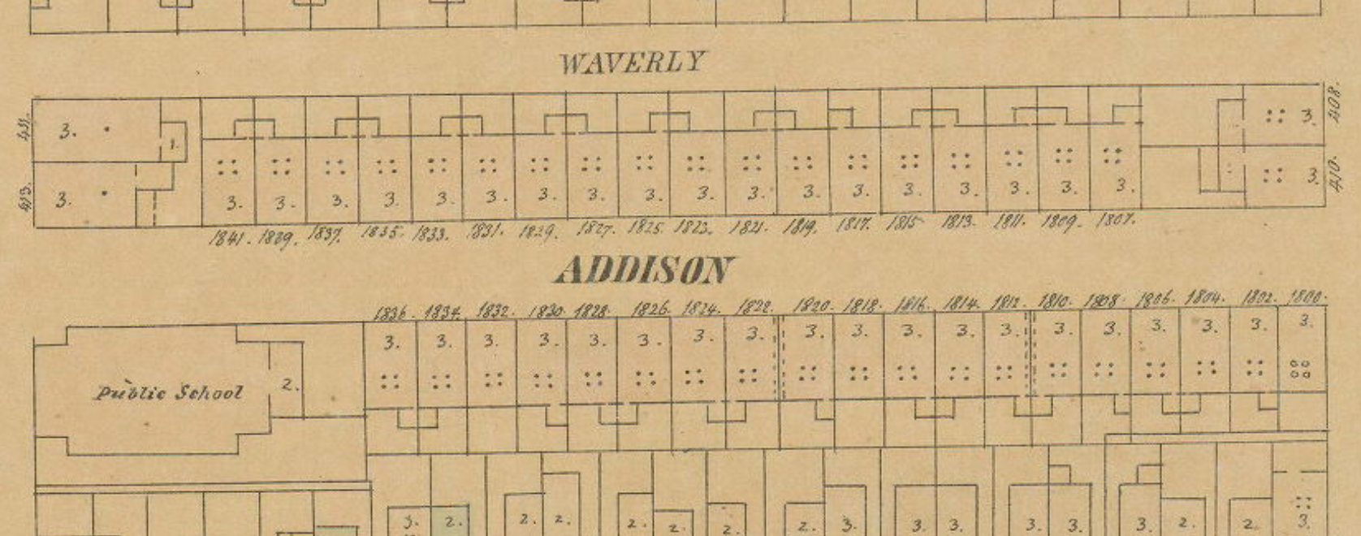opened to one another rather than mediated by the hall, as commonly found today, amplifying the size and brightness of the downstairs spaces. And as in many on the block, the rear frame shed and porch have become a brick expansion accommodating a modern kitchen. The original location of the kitchen is not mentioned in the 1864 survey, but those of similar houses on Addison record its location in the rear of the basement.

**x**

• sw1d. Hexamer & Locher atlas 3: pl. 37 (1858) (PGHN).

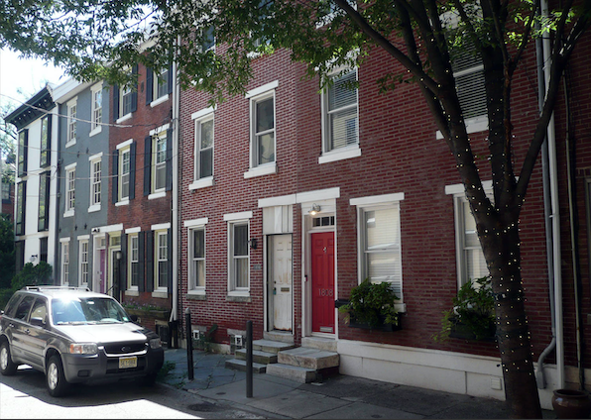• sw1e. 1800-08 Addison, photo 2019, J. Cohen.

The external form of these houses was repetitive and rather prosaic, emblematic of a speculative urban vernacular aimed at occupancy by middling classes, and perhaps at investors who would purchase multiple houses to rent to others. The key marks of distinction between one house and another today lie mainly in later alterations to the fronts, some owed to the materials of which they were originally constructed. Many lintels over windows were wood rather than the marble that would serve this purpose on fashionable blocks to the north, and that choice would beg for replacement in other materials later. And rather than periodic repointing, several houses were painted in a light uniform tone, resurfaced in stucco, covered in applied sheathing, or often by a whole new front in distinct, contrasting brickwork. Wooden cornices, offering a modest classical capping of the whole, generally survive, if sometimes boxed in with sheet metal or replaced by a vertical brick coping. Otherwise, the external form was mainly dictated by the essential elements: a doorway at one edge approached via a few blocky steps of the local gray marble, a rectangular transom light over the front door, and two windows flanking the front door (many of these now replaced by wider parlor windows), while the paired windows on each upper story are presented more symmetrically.

The doorways here were mostly paired with those of the neighboring house, and these were usually aligned with the modest rear extensions, creating a mirroring alternation typical in speculative rows with backbuildings or “ells.” One notable feature here is the narrow doorway in between some houses. Often described in period surveys as “alley built over,” this provided direct access to and from rear yards – more useful on the south side of Addison, which backed directly on the rear yards of houses facing Lombard Street, while houses on the north side of the block had Waverly Street running behind them for yard access.

As with many smaller urban houses, the early social history of these may be told in two sometimes distinct series of names, one of owners and the other of residents, sometimes quite different names. The former is recorded in deeds and fire insurance policies, while the latter is partly reconstructable from city directories (now text-string searchable in some cases) and from census records. George Sheets, the insuring owner of 1810 Addison in 1864, was also resident there between 1861 and 1866. He was listed in city directories of that period as a laborer, and was identified in the 1880 census as a 52-year old, Pennsylvania-born white male (by then residing elsewhere). Before Sheets, in 1858, this was briefly the home of Robert W. Long, a cabinetmaker, and in 1857, when it was called 51 Addison, it was the home of George Rutherford, a carpenter.

Extrapolating the very different pre-1858 addresses from post-1858 ones that stayed in the same occupancy, we can a sample a dozen residents of the block, offering some sense of its vocational identity:

on the South side:

1806 Addison: David Hunter, laborer (47 Addison)

1810 Addison: Geo Rutherford, carpenter (51 Addison)

1812 Addison: James Campbell, grocer (53 Addison)

1814 Addison: Richard M. Leslie, grocer (55 Addison)

1816 Addison: Wm. Steel, spinner (57 Addison)

1820 Addison: Teresa O’Neill, gentw. (61 Addison)

and on the North side:

1809 Addison: W. F. Joyner, painter (46 Addison)

1815 Addison: J. T. Slevin, watches and clocks (52 Addison)

1821 Addison: David T. Lewis, physician, and H. Thienhard (58 Addison)

1827 Addison: Robert Smith, stone cutter (64 Addison)

1831 Addison: Andrew McBurney, clerk (68 Addison)

1837 Addison: Mary Jubert, gentw. (74 Addison)

George Sheets sold 1810 Addison in 1866 to Jabez Pitt Campbell (1815-91), a prominent minister and then bishop of the A.M.E. church, and there are other indications in advertisements from the late 1860s that reflected increasing occupancy by African Americans in the years after emancipation. By the time of W. E. B. Dubois’ mapping in the late 1890s, African Americans had become the dominant population. Dubois found 35 houses on the block occupied by African Americans. He classed three of the households as “poor” (light blue here) seventeen as “working people, fair to comfortable” (green), and fifteen more as of “the middle classes and those above” (red). This and the block of Addison to the east marked the greatest concentration of houses he judged to be of that economic standing in the 7th ward, and this may have held for the whole city. Harvard’s WorldMap, drawn from the 1900 census, confirms this pattern, identifying the black families as mostly southern-born, with an admixture of just a 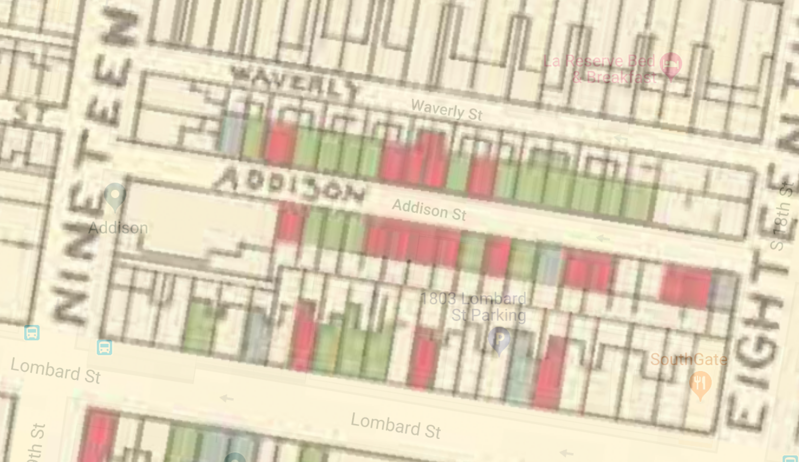few white families – who, strikingly, occupied the whole block of Pine street just to the north, reflecting a pattern evident on many of the blocks north and south of Pine Street.

• sw1f. Excerpt of map of Philadelphia's 7th Ward from W. E. B. Dubois, The Philadelphia Negro (1899) (A. Hillier and S. Boddie, www.dubois-theward.org).

Despite the striking coherence of the houses on this block, the parties involved and their roles in the development -- perhaps tracking the differences in plan -- await further research, especially in order to probe their history before the mid-1850s, where some of our desktop on-line tools give out. But some clues arise.

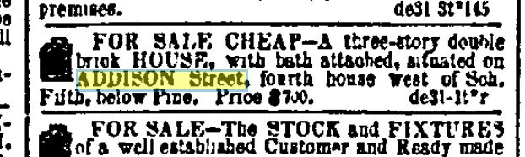An advertisement from late 1852 shows that at least one of the houses, near the east end of the block, was ready for sale for $700. (A reference to a “double brick house” there remains unclear.) With better comparanda, one might be able to assign clearer meaning to the “cheap” price of $700, but the insured value in the 1850s for some of these Addison Street houses ranged from $250 to $400 (which of course may not have reflected their full market value, just a diminished fire loss, and would not include the value of the lot). In 1864, though, 1810 Addison was insured for that amount, $700.

• sw1g. Public Ledger (Philadelphia), December 31, 1852, p. 3.

One set of six houses on the north side of the block, modern numbers 1819-29, were insured together in September 1853 for Thomas and William Bell. (There were several people of this name in city directories, but these may be two carpenters so named, both listed as residing on 13th below, yes, Carpenter Street.) These six houses were slightly wider at 16 feet, and had the more gracious sidehall and wide longitudinal stairhall of 1818 Addison. Though insured by the Bells, each survey was signed on their behalf by John McCrea, one of the most prolific 1840s and 50s developers in this part of the city, responsible for many much larger townhouses just to the north on Spruce, Pine, and Delancey streets. Likewise, an 1862 sheriff’s sale of 1820 Addison offers information on prior ownership, noting that the ground to the east and south of that property was owned at some earlier point by John McCrea and was bounded partly by “other ground intended to be granted to Jacquett Harris.” Harris was listed in an 1860 directory as a carpenter living in West Philadelphia, but in 1855, when the houses were new, he lived at 63 (1822) Addison. One wonders if McCrea, the Bells, and Harris might have been directly connected in the development and construction of these Addison Street rowhouses, with some differences among them attributed to separate building teams, and some deeded to those in building trades as a way of compensating their efforts in terms of temporary ownership rather than cash.

-- JC, with research by Juelun Wei.