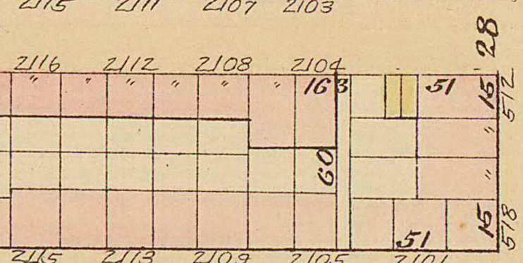 **• sw4. 2112 Naudain Street**

[South of Lombard Street]

Insured in 1849.

16’ front, in likely row of four, 2110-16 Naudain.

X

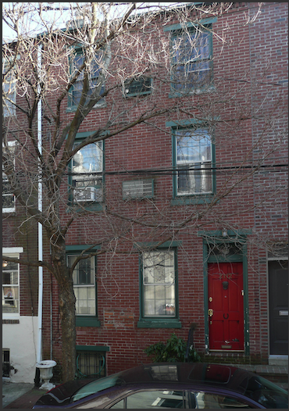**One-cell plans . . . small, inner block streets . . . development and ownership . . . resident demographics . . . Dubois’ 7th ward.**

x

• sw4a. Bromley atlas (1885): pl. Q (PGHN), with south at top.

• sw4b. Photo 2019, J. Cohen.

Single-cell plan houses rarely survive as such in the city. Most seem to date before the dramatic mid-19th century expansion of the city to the north and south facilitated by the horse-drawn streetcar networks, where cheaper land allowed larger houses for working-class families. The older two- and three-story (“trinities”) one-cell houses were mostly located near downtown in the earlier walking-radius city, meaning mainly in dense districts later almost completely claimed by new residential and commercial building at a larger scale.

Where such houses do survive, though, typically on narrow, mid-block streets or courts, their pedestrian proximity to downtown has continued to make them desirable for small households and for seekers of a downtown *pied-a-terre* -- perhaps a few toes short of a full *pied*. Adapting these for modern living has often meant a half or full additional room expansion to the rear, and their characteristic single-pitched roofs often met a lower one, creating a distinctive asymmetric profile.

As mentioned with reference to the Fawn Street house near 12th Street [xref], these small houses were not often built singly. In this case on Naudain several were joined breadthwise as part of a development of small houses rather than in depth behind a larger house. In the early and mid-19th century, this type of development was most often an investment in building for rental, finding ready tenants among populations who often lacked the accumulated capital to own.

At 2110-12 Naudain, two adjoining houses were insured at once in July 1849 by Edward O’Hara, and described as “Two, three story brick dwelling houses, situate on the South side of Williams Street between Schuylkill Second and Front Streets, beginning 102 ft. west of Schuylkill Second Street. The deed registry sheet for block 4-S-16 records O’Hara’s acquisition of the two properties in November 1848 from Robert D. Dunning, who also had owned and sold 2104 and 2106 Naudain around that time, as well as four other properties on the block, including two on the north side. Dunning was listed in 1850 at 7 S. Penn Square, a prestigious address; in 1852 he worked at the U.S. Mint and lived on Filbert St. He seems likely to have been acting as a developer or at least investor, holding several lots and selling them to others, sometimes in pairs.

In 1850 Edward O’Hara was identified as a laborer who resided at 21st and South St., just to the rear of these houses; he would be listed as a grocer on that block the following year. 2110-12 remained in the O’Hara family’s hands until 1908. The 1880 U.S. Census lists Edward, born in Ireland, residing at 2110 with his daughter Mary, and still a retail grocer at age 69. Next door at 2112 were Kate Chambers, keeping house, with two female boarders; all were widows about 60 years old, and also Irish born. O’Hara may have purchased for himself and either for relatives or as a small-scale landlord.

• sw4c. Nationality and ethnicity of Naudain Street residents in 1900 census (WorldMap/ Harvard).

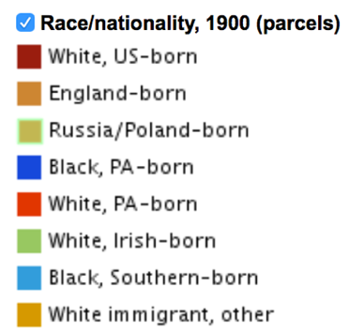• sw4d. Key for 1900 census map.

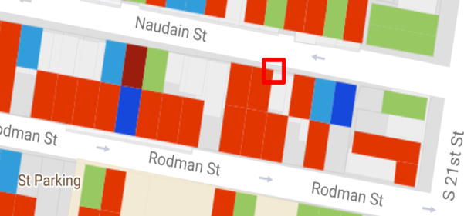

Others on the block were first- or second-generation Irish as well. By 1900, according to the Worldmap project, it was a mixed block, still mostly white, American born, but with a handful of first-generation Irish-born and African American households.

• sw4e. Plan, 1849, Franklin Fire Insurance survey 80: 10456 (HSP).

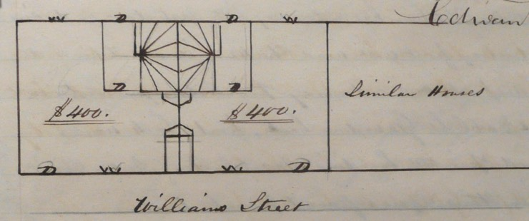As to house form, the survey identified structures to the west as “similar houses,” and they, along with others on the block, may have involved the same developers and builders. The house plan was simple: direct entry into a single squarish space, with the front door near one party wall and the fireplace on the opposite one. Beyond the fireplace was the winding stair, which was partitioned off to occupy nearly a quarter of the plan. The doorway to the yard was located here, near the middle of the back wall. The survey offers more detail: “Hemlock joist, Carolina floor boards, Reveal window frames front wood sills & heads, panel shutters first and venetian to second story, Cased frames back.”

**X**

The survey noted the first-floor front’s “2 12 light 9 by 14 windows” and inside, “plain wood mantel & side closet.” Each house was insured for $400 in 1849.

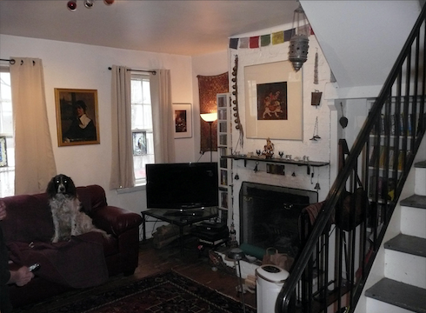• sw4f. Interior, looking northeast, photo 2019, J. Cohen.

Three changes common to such houses are evident here: The winder stair between the ground and second floors has been replaced with a metal one, its enclosure now removed. As in many one-cell houses, a shallow one-story space has been added across the rear to accommodate a modern kitchen. And the present owner reports traces of an old outhouse at the southeast corner of the yard some decades ago, long ago replaced by a toilet on the second-floor. But the house retains its scale, where one appreciates the difference between 16 feet of width and smaller single-cell plans closer to 13 feet wide.

-- JC

=====