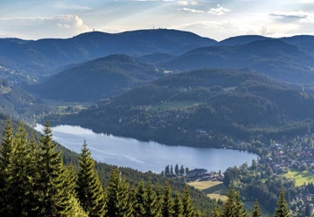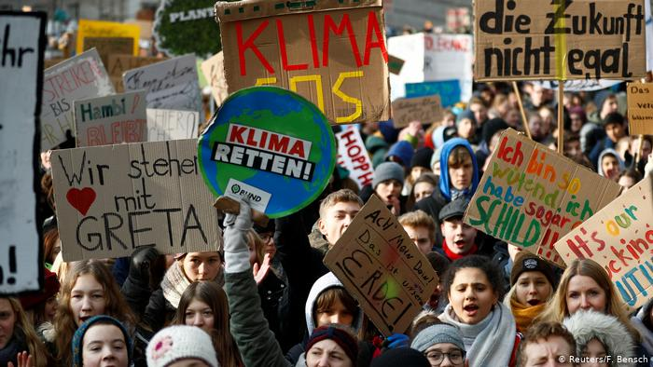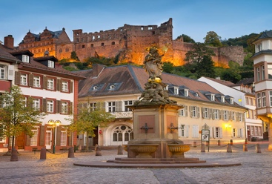

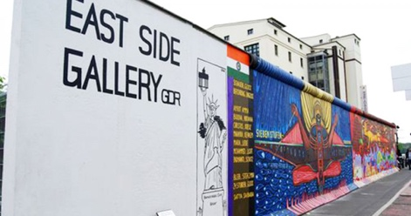

**GERM 001- Elementary German I**

**Grading**

Bryn Mawr Scale:

|  |  |
| --- | --- |
| A 4.0 Excellent  A- 3.7 Excellent-  B+ 3.3 Very Good  B 3.0 Good | B- 2.7 Good-  C+ 2.3 Satisfactory+  C 2.0 Satisfactory |

If the assignment is graded using a scale of 100 points, the letter grade is assigned as follows:

A 93.0 and above A- 90.0 - 92.99

B+ 87.0 - 89.99 B 83.0 - 86.99 B- 80.0 - 82.99

C+ 77.0 - 79.99 C 73.0 - 76.99 C- 70.0 - 72.99

D+ 67.0 - 69.99 D 60.0 - 66.99 F 0.00 - 59.99

**ASSIGNMENTS AND WEIGHT**

**Grades for the first part of the semester up to Kapitel 3 are weighted according to the following percentage breakdowns:**

|  |  |
| --- | --- |
| **Active Participation** | **15%** |
| **Homework/Preparation** | **10%** |
| **Chapter Tests** | **30%** |
| **Quizzes** | **10%** |
| **Weekly Writing Assignments** | **15%** |
| **Interviews** | **10%(1/3 Midterm, 2/3 Final)** |
| **Project** | **10%** |

**Grades for Kapitel 4-6 (including the strike period) will be assessed according to the following breakdown, which reflect reduction of assignments. Green indicates that this category carries over from before the strike.**

|  |  |
| --- | --- |
| **Active Participation** | **15%** |
| **Homework/Preparation** | **15%** |
| **Quest 4 and Quest 5** | **20%** |
| **Quiz Chapter 6** | **5%** |
| **Test Chapter 6 (Final)** | **15%** |
| **Weekly Writing Assignments** | **10%** |
| **Interviews** | **10%(1/3 Midterm, 2/3 Final)** |
| **Projects** | **10%** |

The following adjustment to the semester plan still covers the grammar and vocabulary missed through the Strike, but still allows for the requisite materials to be covered. Attendance and deadlines for all assignments will be enforced after the Strike. The following tips are meant to guide students who are in the process of making up missed work, and provide an overview of the duration of the semester. Exact pacing of material is subject to change:

* Make an appointment in Office Hours to discuss a plan for making up missed work. This can also include adjusted timelines for any work other than Schreibaufgabe 5.2 and 6.1.
  + Aim to have Arbeitsblätter and assignments submitted by Dec 11
  + If your plan involves submitting work beyond Dec 18, we will need to contact your Dean to inform them
  + You are expected to email me when you complete assignments so that I know to look with them .
* Schreibaufgaben with first and second drafts must be completed by the indicated deadlines
* Quest Kapitel 4 will be due by Dec 11
* Quest Kapitel 5 will be due by the indicated deadline, unless individual arrangements are made
* Quiz Kapitel 6 will be due by the indicated deadline, unless individual arrangements are made

Final Interviews will take place during in Zoom during the final exam week or during the final week of classes

Your Final Exam is a longer Kapitel 6 Test that will integrate grammar and vocabulary from the semester. It will be no longer than 90 minutes in duration. You will, however, have all 3 hours allotted for final exams to take it. The listening comprehension will be a separate exam in Moodle, 60 minutes in duration .

Additional Sessions:

* Dec 5 – make up or extra review sessions from 10th and 11th weeks, optional attendance but encouraged especially if you were striking
* Dec 13- Final Exam Review Session over Zoom

If you did not attend the optional sessions during the strike, please complete **one** of the two assignments:

1. Watch the lectures in Moodle and write a 2-3 page double spaced reflection on what you learned, and how the issues surrounding, racism, anti-racism, diversity, equity, and inclusion relate to or are different from those discussions in your country and home city.

2. Read May Ayim’s poem ,,deutschland im herbst” and write a 1,5 – 2 page double spaced analysis of the poem in English. Also include a glossary of 7 relevent words in German you would use to describe this poem.

|  |  |  |
| --- | --- | --- |
| **ZEHNTE WOCHE (KAPITEL 4, S. 155 - 161 )** | | |
| **GRAMMATIK: MODAL VERBEN/ AKK PRÄPOSITIONEN** | | |
| **THEMEN: EIGENSCHAFTEN – ZWEI ANTI-RASSISTISCHE KURZFILME und REISEN** | | |
| **Datum** | **Im Kurs** | **Hausaufgaben (nächste Sitzung fällig)** |
| Montag, 9. November | Eigenschaften  Modalverben  Ausstieg Rechts |  |
| Dienstag, 10. November | AKK Präpositionen  Schwarzfahrer |  |
| Mittwoch, 11. November | Filme vergleichen/Wiederholen |  |
| Donnerstag, 12. November | Wiederholen – Modalverben |  |
| Freitag, 13. November | Wiederholen | Quest Kapitel 4 (Montag)? |

|  |  |  |
| --- | --- | --- |
| **ELFTE WOCHE (KAPITEL 4 & 5, S. 164-179)** | | |
| **GRAMMATIK: DAS PERFEKT** | | |
| **THEMEN: WOHER KOMME ICH? MIGRATION, NATION, HEIMAT** | | |
| **Datum** | **Im Kurs** | **Hausaufgaben (nächste Sitzung fällig)** |
| Montag, 16. November | Wiederholung: Kapitel 4 |  |
| Dienstag, 17. November | Das Perfekt: regular and irregular verbs,  Einwanderung in Deutschland – Migrationskrise in Deutschland |  |
| Mittwoch, 18. November | Das Perfekt üben  Verbs with separable and inseparable prefixes | Cont.d |
| Donnerstag, 19. November | Gründe fürs Auswandern [Text]  Subordinierende Konjunktionen  Perfekt weiter |  |
| Freitag, 20. November | Gründe fürs Auswandern  Weitere Übungen | Video  Lesen  Schreibaufgaben |

**ZWÖLFTE WOCHE**

**--------------------------------------------PAUSE UND UMZUG 21.11 – 29.11 ----------------------------------------------------**

**FERNUNTERRICHT ONLINE STATT PRÄSENSUNTERRICHT (13te Woche – 15te Woche)**

|  |  |  |
| --- | --- | --- |
| **DREIZEHNTE WOCHE (KAPITEL 5, S. 180 – 192)** | | |
| **GRAMMATIK: Zu/Wenn** | | |
| **THEMEN: MIGRATION, HEIMAT, UND INTEGRATION** | | |
| **Datum** | **Im Kurs** | **Hausaufgaben (nächste Sitzung fällig)** |
| Montag, 30. November | Migration/Wiederholung  Push Faktoren | Hörverständnis |
| Dienstag, 1. Dezember | Zu/Wenn  Pull Faktoren | Hörverständnis |
| Mittwoch, 2. Dezember | Zu/Wenn  Wiederholung | **Quest Kapitel 5** |
| Donnerstag, 3. Dezember | **Heimat- Zu Hause oder nicht?**  Haushaltobjekte + Heimat |  |
| Freitag, 4. Dezember | Projekte erklären  Wiederholung |  |

|  |  |  |
| --- | --- | --- |
| **VIERZEHNTE WOCHE +++Interview 2+++ (KAPITEL 5 &6, S. 193-202)** | | |
| **GRAMMATIK:** | | |
| **THEMEN: HEIMAT , RECHTE UND PFLICHTE** | | |
| **Datum** | **Im Kurs** | **Hausaufgaben (nächste Sitzung fällig)** |
| Montag, 7. Dezember | Meine Rechte und Pflichte |  |
| Dienstag, 8. Dezember | DAT |  |
| Mittwoch, 9. Dezember | DAT Präpositionen und Verben |  |
| Donnerstag, 10. Dezember | Wiederholung | **Quiz 6; Schreibaufgaben10 gegeben**: |
| Freitag,11. Dezember | Kein Unterricht |  |

|  |  |
| --- | --- |
| **FÜNFZEHNTE WOCHE (KAPITEL 6)** | |
| **EXAMENWOCHE** | |
|  | |
| **Datum** | **-Self scheduled (in Moodle) Kapitel 6 Test [und andere Kapitel]**  **-Interview II cont’d**  **-Schreibaufgabe 10**  **-Projekte fällig** |
| Montag, 14. Dezember |
| Dienstag, 15. Dezember |
| Mittwoch, 16. Dezember |
| Donnerstag, 17. Dezember |
| Freitag, 18. Dezember | Winterferien! |

**SEMESTERPLAN FÜR DIE SCHREIBAUFGABEN -REVIDIERT**

|  |  |  |
| --- | --- | --- |
| 12 | 24.11 (Dienstag)  27.11 (Freitag) | **PAUSE UND UMZUG**  **Schreibaufgabe 7,1 fällig**  **5,2 und 6,1 fällig** |
| 13 | 30.11 (Montag)  2. 12 (Mittwoch)  4.12 (Freitag) | Schreibaufgaben 6,1 und 7,1 zurück  Schreibaufgabe 8,1 fällig  Schreibaufgaben 6,2 und 7,2 fällig, Schreibaufgabe 8,1 zurück; Schreibaufgabe 9,1 gepostet |
| 14 | 7.12 (Montag)  11.12 (Freitag) | Schreibaufgabe 9,1 fällig  Schreibaufgabe 9,2 fällig; Schreibaufgabe 10 gepostet |
| 15 | 14.12 (Montag)  18.12 (Freitag) | Schreibaufgabe 10 fällig |

**PROJEKTE**

**You may pick one of the four options to complete as a final project.**

**Option 1: Expansion of Schreibaufgabe 7 – Expand to approximately 1,5 pages double spaced- why have you made the choices that you have for adapting this film for the year 2020? Remember you are focusing on the passengers and description. Complete the attached thought organizer to shape your thoughts. Design/visual element also included will be discussed on Friday Dec 4 in class.**

**Option 2: Expansion of Schreibaufgabe 8 – Expand to approximately 1,5 pages double spaced and write seven additional interview questions in German to then ask this person (in language of choice for communicating with your family member or friend.**

**Option 3: Expansion of Schreibaufgabe 9 -- Was bedeutet Heimat für mich? What is Heimat for you? What determines your feeling of being at home and belonging? If you could pick one object or image that represents that feeling for you, what would it be and why? From the optional sessions, we’ve learned that Heimat has been appropriated by the far right in Germany, but that efforts are underway to reclaim and make the word a more inclusive term, applicable to all. How do you make it applicable to you and your experiences?**

**Visual element: the picture or picture of an object that represents Heimat the best for you and include a short description of it.**

**Option 4: Anti-Rassismus Aktivitäten und Initiative in Deutschland. During the optional sessions we talked about some anti-racist initiatives and activism in Germany. Find out more any one of these organizations or initiatives (listed in the resource slides). These may include Initiative Schwarze Menschen in Deutschland, Amadeau Antonio Stiftung, Each One Teach One, and write 1 page in German double-spaced about the organization, its aims, where it is based, how old it is, recent events or initiatives it has undertaken, are there prominent members or leaders of it? If so, who are they, what do they do? Why do they do it?**